**Name: Ahmad Zaidan bin Adnan (1718733)**

**Section 6**

**Question 1**

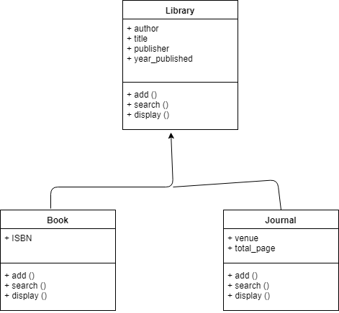

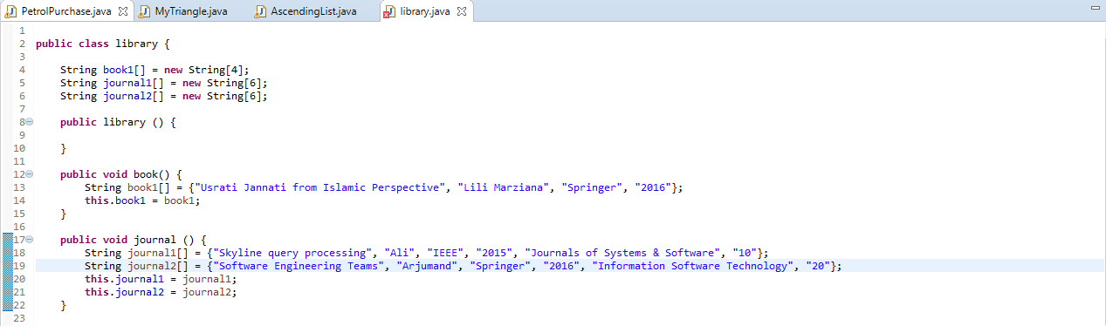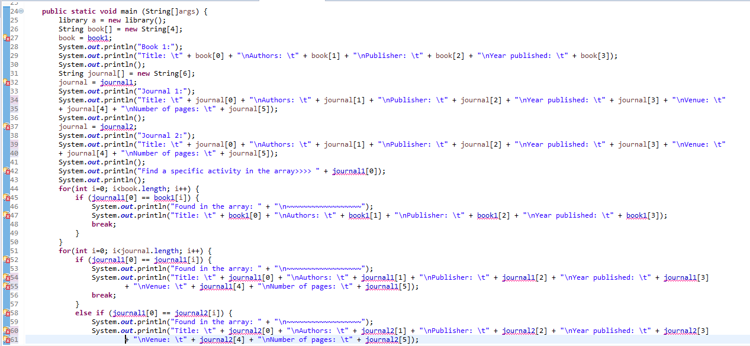

**Question 2**

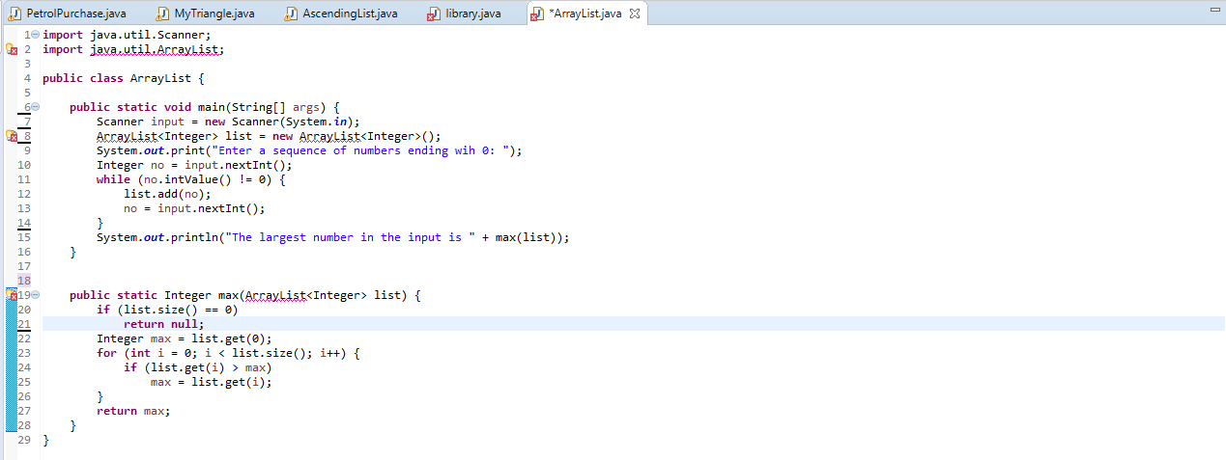

**Question 3**

